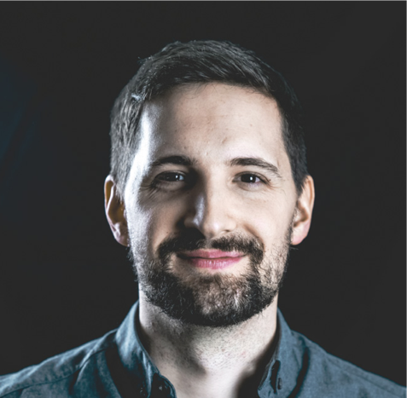

**PRODUCTIONS**

***WINTERFEST:*** Clown, Acrobat, Animation:Salzburg, Austria: 12/2021

***CIRCUS MONTI, TOUR 2021:*** Clown, Acrobat: Switzerland: 6/2021-12/2021

***HO HO HOLIDAY- Online Show,*** Performer, Clown: December 2020

***LATE NIGHT SHOW 02-*** Cirk La Putyka Tv Production, Performer, Clown: Czech Republic: 12/2020

***TRUTNOV FESTIVAL-*** Cirk La Putyka, Performer, Clown:

Czech Republic: 9/2020

***KABARETT DYNAMO –*** Cirk La Putyka, Performer, Clown: Czech Republic: 7/2020-9/2020

***NO STAGE NO PROBLEM- Online Show***, Performer, Clown: April 2020

**STUDIED WITH**

***Olivia Swoboda-Weinstein:*** 2019-present

***Spencer Novich:*** 2020-present

***Les Deux de Pique : (Philippe Trépanier and Tamara Bousquet)-*** 2019-2020

**Stefan Swoboda**

*PERFORMER, CLOWN*

Born on 16.07.1990  
in 2130 Mistelbach, Austria

E-Mail: stefanswoboda@gmx.net Phone: +43 680 110 46 78

Address: Weinberggasse 3,  
2115 Ernstbrunn, Austria

Hair: Brown

Eyes: Brown

Height: 1m77cm

Weight: 72KG